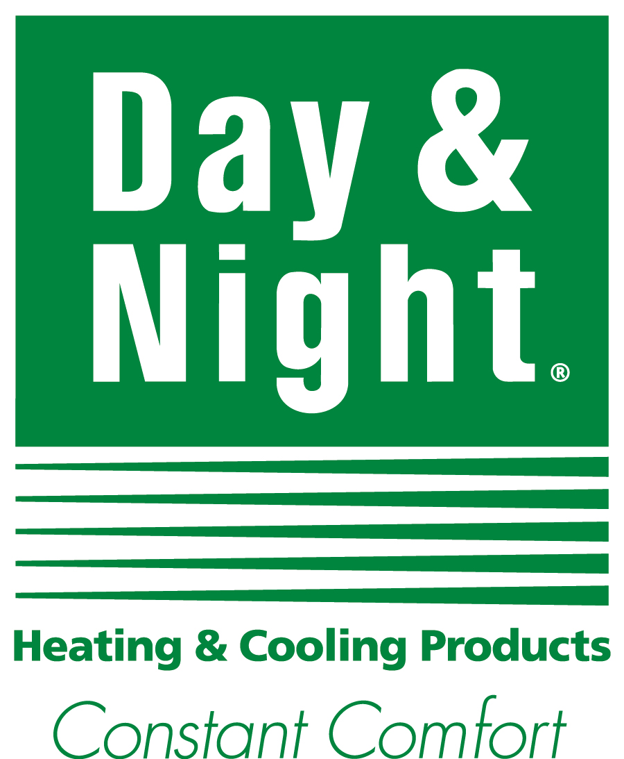

**Email Copy**

**JOB #: 15-ICP-0090**

**DATE: Nov 18, 2015**

***Product Excellence***

SUBJECT LINE:

**Depend on us to keep you cool all summer long.**

HEADLINE:

**Needs vary, dependability doesn’t.**

COPY:

We have everything you need to keep your home cool and comfortable all summer long, from complete cooling systems to the latest in Wi-Fi® capable thermostats. Our work is as dependable as the Day & Night® systems we install. That’s why you should make <DEALER NAME> your first and only call for all your cooling needs.

Call (555) 123-4567 or find us online at AbcHVAC.com

Day & Night. Constant Comfort.

Version 2

SUBJECT LINE:

**Everything you need to keep your home cool.**

HEADLINE:

**If it cools what's under your roof, we keep it under ours.**

COPY:

When we say we have everything you need to keep your house cool and comfortable all summer, we mean *everything.* From complete cooling systems to the latest in Wi-Fi® capable thermostats, we deliver outstanding, reliable products that you and your family can depend on to keep you comfortable, no matter what summer brings. Make <DEALER NAME> your first call for all your cooling needs.

Call (555) 123-4567 or find us online at AbcHVAC.com

Day & Night. Constant Comfort.

***Dealer Quality***

SUBJECT LINE:

**We’ll keep you comfortable all summer long.**

HEADLINE:

**Honesty and integrity are always included.**

COPY:

You can depend on <DEALER NAME> to keep your home and family comfortable all summer long. Whether it’s a spring tune-up or a mid-summer emergency repair call, our customers enjoy the peace of mind that comes from having a reliable relationship with a rock-solid service partner. Make us your first and only call for outstanding cooling products and solutions.

Call (555) 123-4567 or find us online at AbcHVAC.com

Day & Night. Constant Comfort.

Version 2

SUBJECT LINE:

**Dependability is always included.**

HEADLINE:

**Quality doesn’t cost extra.**

COPY:

You can depend on <DEALER NAME> to keep your home and family comfortable all summer long. Whether it’s a spring tune-up or a mid-summer emergency repair call, our customers enjoy the peace of mind that comes from having a reliable relationship with a rock-solid service partner. Make us your first and only call for outstanding cooling products and solutions.

Call (555) 123-4567 or find us online at AbcHVAC.com

Day & Night. Constant Comfort.

***Service***

Version 1

SUBJECT LINE:

**Don’t let your A/C derail your summer vacation.**

HEADLINE:

**You’re ready for summer. Is your air conditioner?**

COPY:

Summer heat and humidity can push your cooling system to the limit. Make sure it’s ready with a tune-up from <DEALER NAME>. A little preventive maintenance can spot problems before they pop up and might even help lower your utility bills. Call <DEALER NAME> today and enjoy cool, comfortable peace of mind all summer long.

Call (555) 123-4567 or find us online at AbcHVAC.com

Day & Night. Constant Comfort.

Version 2

SUBJECT LINE:

**An A/C tune-up now prevents a repair call later.**

HEADLINE:

**Tell Mother Nature you’ll choose the temperature in your den, thank you very much.**

COPY:

Summer heat and humidity can push your cooling system to the limit. Make sure it’s up to the challenge with a tune-up from <DEALER NAME>. A little preventive maintenance can spot problems before they pop up and might even help lower your utility bills. Call us today and enjoy cool, comfortable peace of mind all summer long.

Call (555) 123-4567 or find us online at AbcHVAC.com

Day & Night. Constant Comfort.